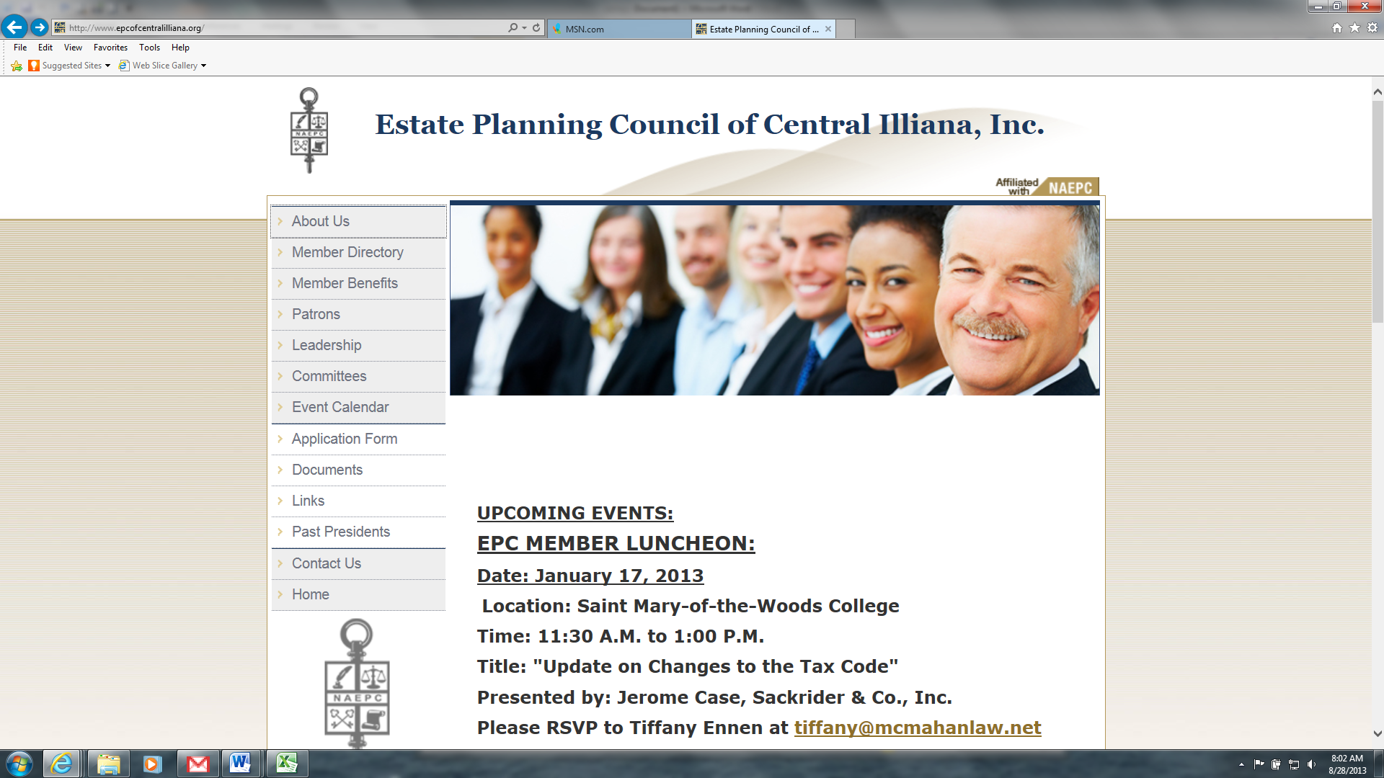

# MEMBERSHIP RENEWAL NOTICE

September 9, 2020

Dear Estate Planning Professional:

It is time to renew your membership in the Estate Planning Council of Central llliana, Inc. We recently elected new officers and board members and we're excited to provide another year of timely, informative programs and services to benefit you as a member. We have scheduled professional programs and speakers for each of our 2020-2021 membership meetings with topics of interest to various disciplines. **Except for October, all meetings are held the 3rd Thursday of the month beginning in September, January, March and May.** Listed below are our planned dates so please mark your calendars and plan to join us.

* Thursday, September 17, 2020 Kit MacNee, Behavioral Finance

## Professional Advisor's Seminar - Wabash Valley Community Foundation, Date and time--TBD

* Thursday, January 21, 2021
* Thursday, March 18, 2021
* Thursday, May 20, 2021 Lance Like, Like Law Group

To keep you informed of upcoming events, please save this website, www.epcofcentralilliana.org, as a favorite so you'll have quick access to it! There you'll find information on each of the meetings and other informative topics and articles.

We count on your continued membership and your involvement to keep this organization viable. This is an excellent way to network with peers and members of other disciplines as well as the opportunity to hear current information regarding estate planning. The board members encourage your feedback, ideas and participation on programs and speakers.

Due to the Covid-19 and starting our meetings using Zoom, the board has reduced the fees for all members to $99 for this year only for new and renewing members.(Individual and Group Memberships are only $99) Please share this opportunity with other professionals and encourage them to apply for membership as well.

Sincerely,

E. Brady Hansel, President