The Estate Planning Council of Central Illiana invites you to attend our Health Care Update 2014.  
Thursday, January 16th   
11:30a.m.-1:00p.m. at Saint Mary-of-the-Woods College

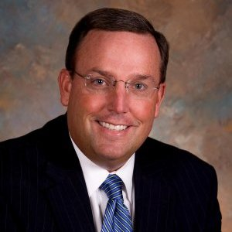

Pat Carney, Vice President, Employee Benefits, Old National Insurance.- With over 22 years of experience, Pat offers consulting, advising and strategizing with employers on their employee benefit offerings. This includes, but is not limited to benefit management, vendor management, compliance management, technology management and health population management.

[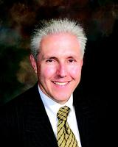](http://www.tribstar.com/archive/x983024177)

Patrick S. Board, President and CEO, Union Health System, Inc. (UHS)

Pat Board currently serves as CEO of Union Associated Physicians Clinic, LLC, (UAP) in Terre Haute. The UAP Clinic is a multi-specialty group medical practice and which is part of UHS. These excellent resources serve patients throughout west central Indiana and east central Illinois.

NOTE: Our meeting will be in a different room location. Please join us in the Former Parlor in the Le Fer Ballroom. It is the parlor to your right when walking into the front doors of Le Fer.  For your convenience I have added a link with the SMWC campus map. Le Fer Hall is the large building on your right just as you enter the campus. **Parking**: is on the avenue – walk in the front doors of Le Fer. <http://www.smwc.edu/about/campus-map/>

We are pleased to have Pat Carney and Pat Board for our meeting and believe they will provide valuable insight for our members. RSVP to [bdyer@thsb.com](mailto:bdyer@thsb.com) by Monday, January 13th. Questions, contact Brian at 812-244-5192. Reminder: The cost of lunch is included in your membership.